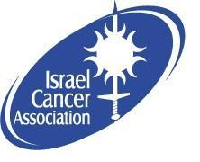
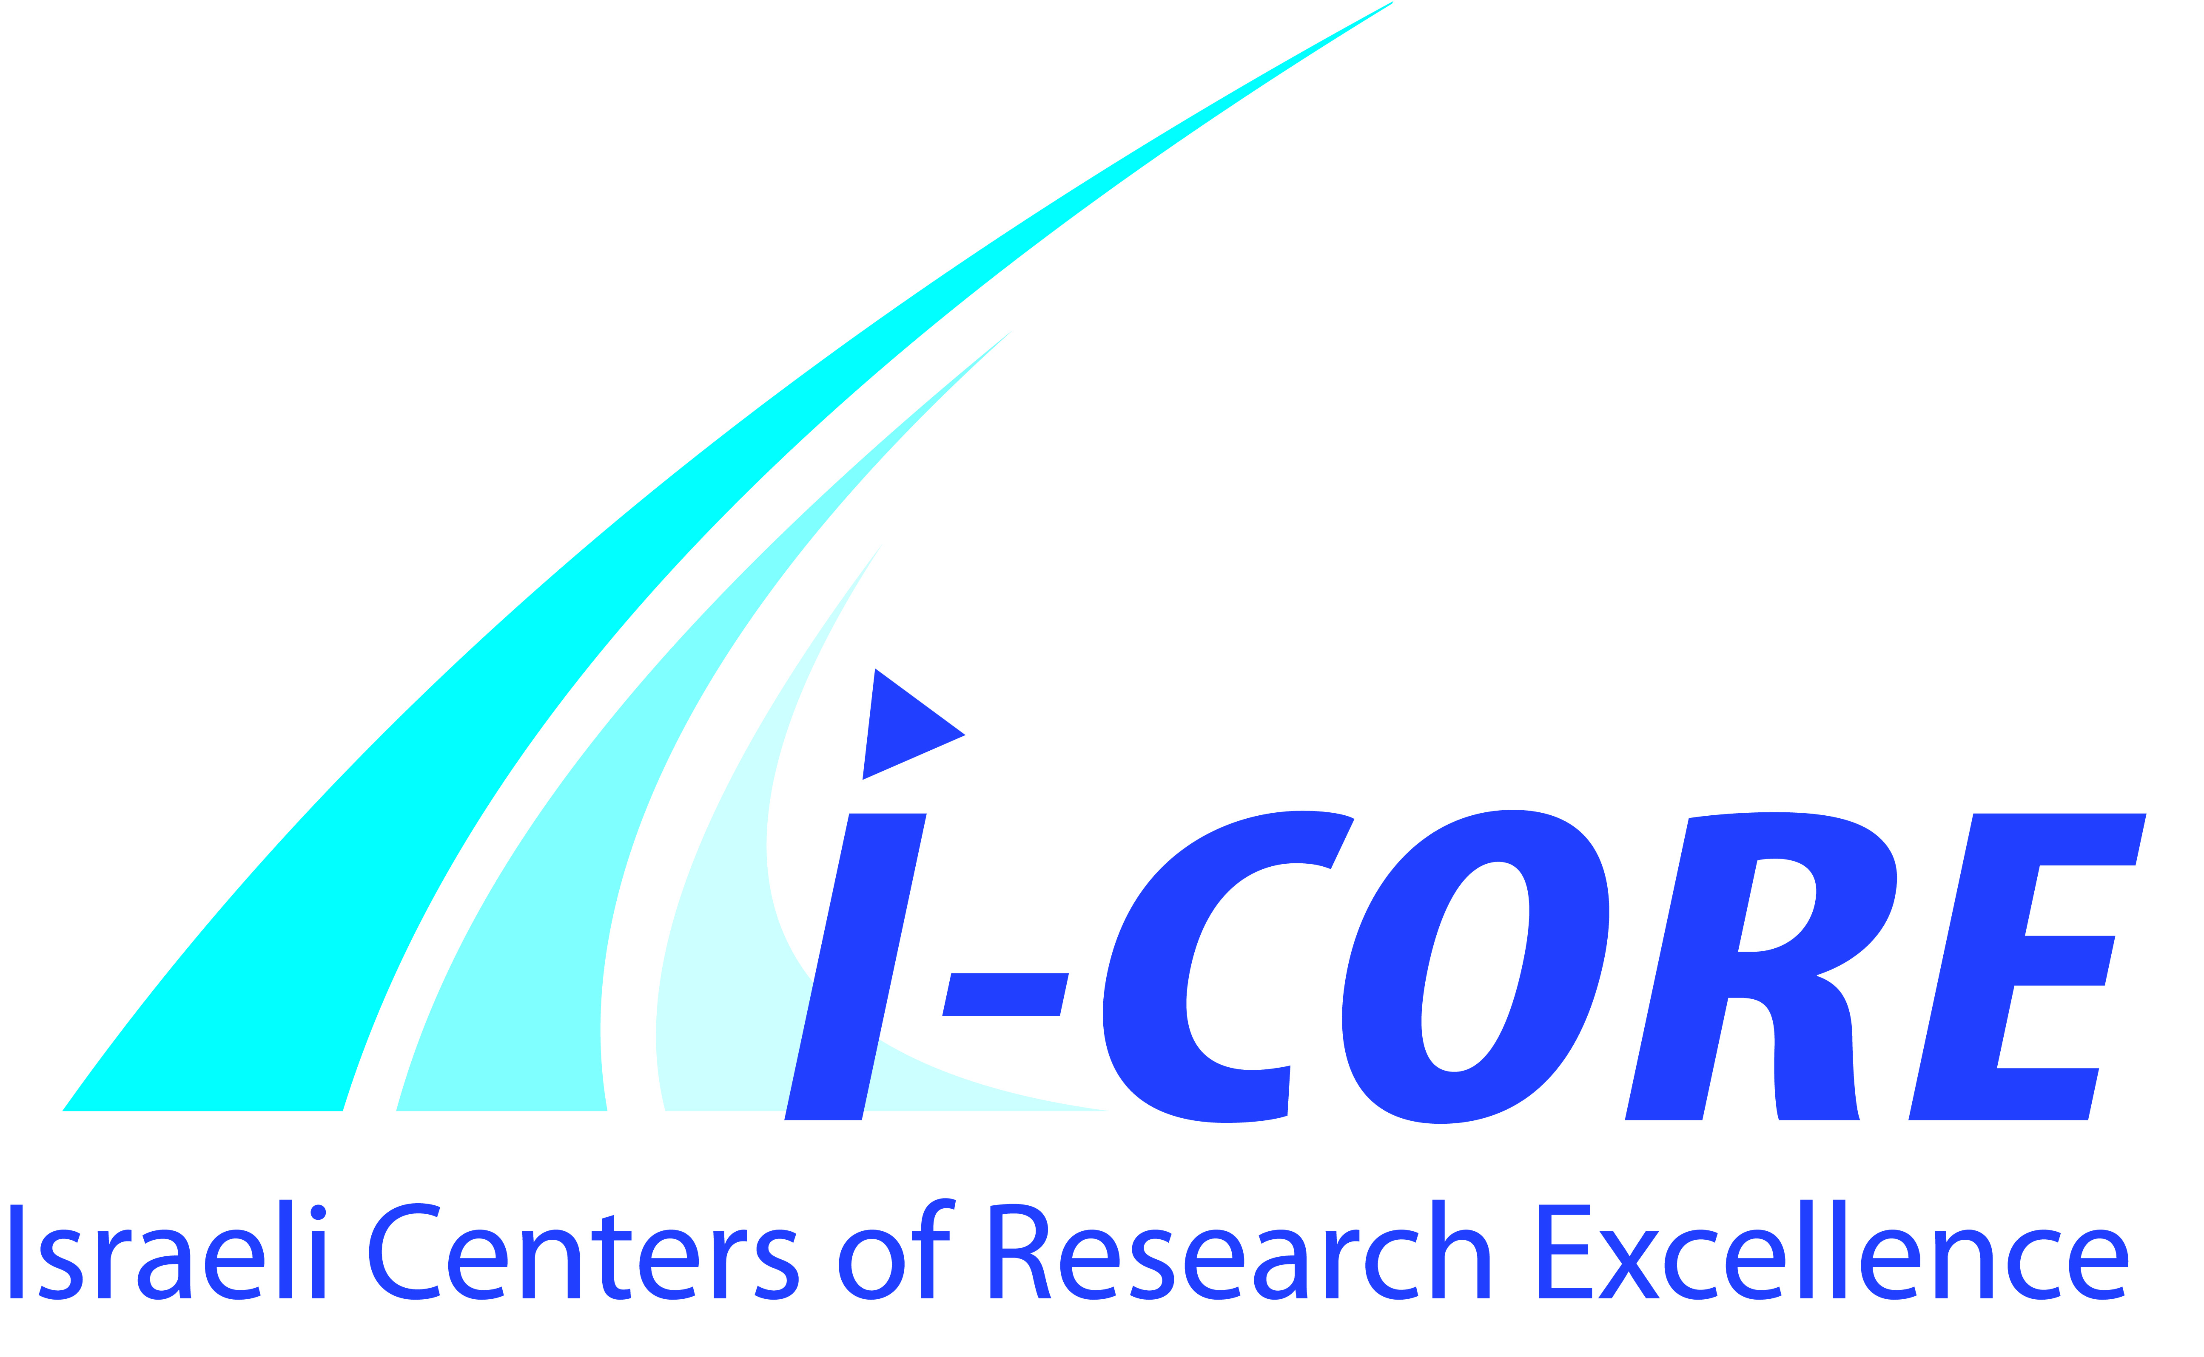
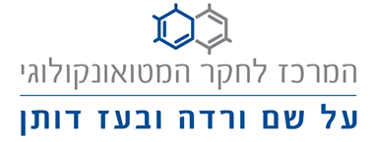
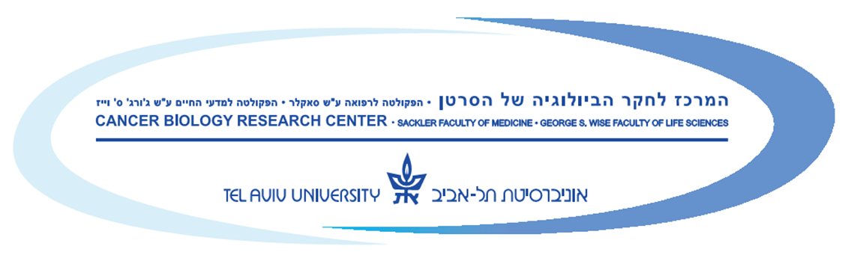
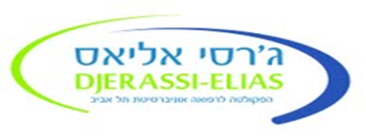
Cancer Biology Research Center
17th Biennial Conference

Royal Rimonim Dead Sea Hotel

November 11-14, 2015

Wednesday, November 11, 2015

13:30 - 14:30 Registration and Reception
14:30 - 14:40 | Opening Session
OPENING AND GREETINGS
Joseph Klafter, President, Tel Aviv University
Daniel Chamovitz, Dean, Faculty of Life Sciences
Miri Ziv, Director, Israel Cancer Association
Nadir Arber, Head, Cancer Biology Research Center
14:40 - 16:00 | Session I TRIBUTE TO PRINCESS MARGARET
Chairs: Shai Izraeli, Sheba Medical Center
Robert Rottapel, Princess Margaret Cancer Centre
14:40 - 15:00 REGULATION OF PHENOTYPIC DIVERSITY THROUGH OXYGEN SENSITIVE SIGNALING PATHWAYS
Brad Wouters - Princess Margaret Cancer Centre
15:00 - 15:20 Self-renewal and the origins of leukemia
Norman Iscove - Princess Margaret Cancer Centre
15:20 - 15:40 Multiple Myeloma tumor progenitors: role in drug resistance and relapse
Rodger Tiedemann - Princess Margaret Cancer Centre
15:40 - 16:00 TREATMENT OF MULTIPLE MYELOMA USING CAR REDIRECTED T CELLS
Zelig Eshhar - Tel-Aviv Sourasky Medical Center
16:00 - 16:30 C o f f e e B r e a k
16:30 -18:15 | Session II DIAGNOSTICS AND THERAPEUTICS
Chairs: Boaz Tadmor, Rabin Medical Center
Raphael Catane, Sheba Medical Center
16:30 - 16:45 GLYCO-NANOPARTICLES FOR CANCER VACCINE
Vered Padler-Karavani Tel Aviv University (Life Sci.)
16:45 - 17:00 TELOMERASE AS A TARGET FOR CANCER THERAPY
Meir Lahav - Rabin Medical Center
17:00 - 17:15 THE HORMONE KLOTHO: A NOVEL REGULATOR OF TUMOR METABOLISM
Tami Rubinek - Tel-Aviv Sourasky Medical Center
17:15 - 17:30 TYROSINE KINASE INHIBITORS AND CARDIOVASCULAR DISEASE
Pia Raanani - Rabin Medical Center
Wednesday, NOVEMBER 11, 2015 (cont’d)

17:30 - 17:45 WHAT IS NEW IN OVARIAN CANCER?
Tamar Safra - Tel-Aviv Sourasky Medical Center
17:45 - 17:55 SECRETOME OF BONE MARROW MESENCHYMAL STEM CELLS: AN EMERGING PLAYER IN LUNG CANCER PROGRESSION AND MECHANISM OF TRANSLATION INITIATION
Oshrat Attar-Schneider - Meir Medical Center
17:55 - 18:05 microRNA-BASED NANOGELS FOR COMBATING GLIOBLASTOMA
Zohar Shatsberg - Tel Aviv University (Med.)
18:05 - 18:15 PROMIS-QUAN: A NOVEL PROTEOMIC METHOD FOR THE DISCOVERY OF BLOOD-BASED CANCER BIOMARKERS
Michal Harel - Tel Aviv University (Med.)
18:20 - 18:45 | Flash Session 1
Chair: Drorit Neumann, Tel Aviv University (Med.)
18:20 -18:25 HIGH THROUGHPUT SCREENING OF PRIMARY VERSUS METASTATIC ISOGENIC CELL-LINES REVEALS A NOVEL ROLE FOR SNX18 IN MIGRATION OF MELANOMA
Maya Goshen - Sheba Medical Center
18:25 -18:30 REGULATION OF CEACAM1 PROTEIN EXPRESSION IN BRAF-MUTANT HUMAN METASTATIC MELANOMA CELLS
Karin Kfir - Sheba Medical Center
18:30 -18:35 GLOBAL PROTEOMIC PROFILING OF RESPONSE TO NEOADJUVANT CHEMOTHERAPY IN LOCALLY ADVANCED BREAST CANCER
Anjana Shenoy - Tel Aviv University (Med.)
18:35 -18:40 DUAL MTOR INHIBITION: A NOVEL TREATMENT STRATEGY TO OVERCOME ENDOCRINE RESISTANCE CAUSED BY ACQUIRED MUTATIONS OF ESTROGEN RECEPTOR (ER) ALPHA
Lotem Shpigner - Tel Aviv Sourasky Medical Center
18:40 -18:45 IN VIVO MOLECULAR IMAGING OF HIF-1α AND SEPTIN 9 INTERACTION BY BIMOLECULAR FLUORESCENCE COMPLEMENTATION
Maya Golan - Tel Aviv Sourasky Medical Center
20:00 D i n n e r
21:30 SPECIAL GUEST LECTURE
Yohanan Danino - 17th chief of Israel Police

THURSDAY, NOVEMBER 12, 2015

07:00 - 08:00 B r e a k f a s t
08:00 - 08:40 Meet the Expert
John Dick, Robert Rottapel, Brad Wouters, Rama Khokha
08:40 - 10:10 | Session III MICE ARE NOT ALONE - ALTERNATIVE  PRE-CLINICAL MODELS
Chairs: Neta Erez, Tel Aviv University (Med.)
Nir Peled, Rabin Medical Center
08:40 - 09:00 INTRODUCTION TALK
ADULT MAMMARY STEM CELLS AND BREAST CANCER.
Rama Khokha - Princess Margaret Cancer Centre
09:00 - 09:15 NEW ASPECTS IN MELANOMA MICRO ENVIRONMENT
Carmit Levy - Tel Aviv University (Med.)
09:15 - 09:25 ASTROGLIOSIS IS INSTIGATED IN A NOVEL MOUSE MODEL OF SPONTANEOUS MELANOMA BRAIN METASTASIS
Hila Schwartz - Tel Aviv University (Med.)
09:25 -10:00 KEYNOTE LECTURE
DEVELOPING THE NEXT GENERATION OF ANGIOGENESIS INHIBITION WITH VANUCIZUMAB, A NOVEL BI-SPECIFIC HUMAN ANTIBODY AGAINST ANG-2 AND VEGF-A
Oliver Krieter - Roche Pharmaceuticals Research & Early Development
10:00 - 10:30 Coffee Break and Visit the Exhibition
10:30 -12.00 | Session IV IMMUNOTHERAPY - PD1 INHIBITORS AND BEYOND
Chairs: Yoav Henis, Vice President for R&D, Tel Aviv University
Gal Markel, Sheba Medical Center
10:30 - 10:45 Studying design principles for bi-specific IgGs – the H-L pairing challenge
Itai Benhar - Tel Aviv University (Life Sci.)
10:45 - 11:00 GLIOMA INDUCED IMMUNE ACTIVATION - THE GLASS HALF FULL
Ilan Volovitz - Tel Aviv Sourasky Medical Center
11:00 - 11:15 TUMOR-ASSOCIATED MACROPHAGES PROMOTE TUMOR DEVELOPMENT THROUGH REMODELING OF ITS EXTRACELLULAR MATRIX
Chen Varol - Tel-Aviv Sourasky Medical Center
THURSDAY, NOVEMBER 12, 2015 (cont’d)

11:15 - 11:30 PRECISION THERAPY: THE WIZARD EXPECTATIONS
Raanan Berger - Sheba Medical Center
11:30 - 11:45 NATURE AS AN AID TO CANCER THERAPY: TOXIN-ANTI-TOXIN CONCEPT
Shiran Shapira - Tel-Aviv Sourasky Medical Center
11:45 - 11:55 ADOPTIVE CELL THERAPY WITH TUMOR INFILTRATING LYMPHOCYTES: CLINICAL RESULTS AND CORRELATION TO CLINICAL SUCCESS
Michal Besser - Sheba Medical Center
12:00 - 13:10 | Session V METHODOLOGIES
Chair: Irit Ben-Aharon, Rabin Medical Center
Ronit Satchi-Fainaro, Tel Aviv University (Med.)
12:00 - 12:15 PROTEOMICS
Tami Geiger - Tel Aviv University (Med.)
12:15 - 12:30 MAPPING OF EPIGENETIC MARKS AND DNA DAMAGE SITES ON INDIVIDUAL DNA MOLECULES
Yuval Ebenstein - Tel Aviv University (Exact Sci.)
12:30 - 13:00 HOW TO READ NGS?
• THE SCIENTIST’S PERSPECTIVE:
EXPLORATION OF NOVEL REGULATORY LAYERS USING NGS
Rani Elkon - Tel Aviv University (Med.)
• THE GENETICIST’S PERSPECTIVE:
Eitan Friedman - Sheba Medical Center, Tel Hashomer
• THE ONCOLOGIST’S PERSPECTIVE:
Ravit Geva - Tel Aviv Sourasky Medical Center
13:00 - 13:10 METHODS IDENTIFYING NEOANTIGEN SPECIFIC T CELLS FOR IMMUNOTHERAPY
Efrat Merhavi-Shoham - Sheba Medical Center

13:15 - 14:30 Djerassi Legacy - Brain Storming Lunch
HEMATOLOGICAL MALIGNANCIES
Pia Raanani, Shai Izraeli, Rodger Tiedemann, John Dick,
Norman Iscove, Mario Dicato
THURSDAY, NOVEMBER 12, 2015 (cont’d)

GI MALIGNANCIES
Baruch Brenner, Ravit Geva, Nadir Arber, Catherine O'Brien
BREAST MALIGNANCIES
Ella Evron, Neta Erez, Eitan Friedman
TRANSLATIONAL RESEARCH:
Oliver Krieter, Ilan Volovitz, Meir Lahav
ADVANCED TECHNOLOGIES USED FOR DEEP MEDICAL UNDERSTANDING
Vered Padler-Karavani, Ariel Munitz, Noam Shomron
14:30 - 16:30 | Session VI HEMATOLOGICAL MALIGNANCIES –  Dotan Award Laureates
Chair: Maya Koren-Michowitz, Assaf Harofe Medical Center
Pia Raanani, Rabin Medical Center
STUDIES AT THE FOREFRONT OF HEMATOLOGY RESEARCH
14:30 - 14:50 Targeting Mantle Cell Lymphoma (MCL) with Nanomedicines
Dan Peer - Tel Aviv University (Life Sci.)
14:50 - 15:10 INTRACELLULAR αVβ3 INTEGRIN AND NUCLEAR IGF1 RECEPTOR
Osnat Ashur-Fabian - Meir Medical Center
15:10 - 15:30 Eosinophils: The Forgotten Cells of the Tumor Microenvironment
Ariel Munitz - Tel Aviv University (Med.)
15:30 - 15:50 NOVEL SIGNALING PATHWAY IN CLL – PATHOPHYSIOLOGY AND NEW TARGET FOR THERAPY
Yair Herishanu - Tel-Aviv Sourasky Medical Center
15:50 - 16:10 ERG AS AN HEMATOPOIETIC ONCOGENE – CHALLENGES AND OPPORTUNITIES
Shai Izraeli - Sheba Medical Center
16:10 - 16:20 BONE MARROW MESNCHYMAL STEM CELLS` CONDITIONING BY MULTIPLE MYELOMA CELLS: TRANSLATION INITIATION AS THE PLAYING FIELD
Mahmoud Dabbah - Meir Medical Center
16:20 - 16:30 ERYTHROPOIETIN MEDIATED IMMUNO-SKELETAL EFFECTS IN MULTIPLE MYELOMA - A FRIEND AND FOE.
Naamit Deshet-Unger - Tel Aviv University (Med.)

THURSDAY, NOVEMBER 12, 2015 (cont’d)

16:30 - 17:15 Coffee Break and Visit the Exhibition
17:15-18:15 | Session VII BIOINFORMATICS
Chairs: Metsada Pasmanik-Chor, Tel Aviv University (Life Sci.)
Noam Shomron, Tel Aviv University (Med.)
17:15 - 17:30 A NETWORK-BASED ANALYSIS OF COLON CANCER SPLICING CHANGES REVEALS A NOVEL REGULATORY PATHWAY
Gil Ast - Tel Aviv University (Med.)
17:30 - 17:45 STATISTICAL ANALYSIS OF GENOME-WIDE ASSOCIATION STUDIES: CLASSICAL METHODS AND MODERN TWISTS
Saharon Rosset - Tel Aviv University (Exact Sci.)
17:45 - 18:00 CHEMOTHERAPY-INDUCED VASCULAR TOXICITY: THE SEED OF EVIL?
Irit Ben-Aharon - Rabin Medical Center
18:00 - 18:07 COMPREHENSIVE MOLECULAR PROFILING OF TUMOR EVOLUTION IN RESPONSE TO NEOADJUVANT TREATMENT OF BREAST CANCER
Maya Dadiani - Sheba Medical Center
18:07 - 18:15 THE CROSSTALK BETWEEN OMENTAL FAT AND TUMOR CELLS IN GASTROINTESTINAL MALIGNANCIES
Shelly Loewenstein - Tel-Aviv Sourasky Medical Center
18:15 - 20:15 Poster Viewing and Visit the Exhibition
20:30 D i n n e r
21:30 DANNY SANDERSON LIVE!!

FRIDAY, NoVEMBER 13, 2015
07:00 - 08:00 B r e a k f a s t
08:00 - 08:45 Meet the Expert
Catherine O’Brien, Rodger Tiedemann, Norman Iscove, Mario Dicato
08:45 -10:15 | Session VIII CANCER STEM CELL OR TUMOR INITIATING CELLS?
Chairs: Yehudit Birger, Sheba Medical Center
Mario Dicato, University of Luxemburg
08:45 - 09:05 INTRODUCTION TALK:
Self-renewal as a therapeutic target in colorectal cancer
Catherine O’Brien - Princess Margaret Cancer Centre
09:05 - 09:20 De-differentiation and Reprogramming: Origins of Cancer Stem Cells
Dinorah Friedmann-Morvinski - Tel Aviv University (Life Sci.)
09:20 - 09:35 EARLY DIFFERENTIATION DYNAMICS IN EMBRYOID BODIES‬
Iftach Nachman - Tel Aviv University (Life Sci.)
09:35 - 09:50 REGULATION OF HEMATOPOIESIS: NORMAL AND LEUKEMIA STEM CELLS
Michael Milyavsky - Tel Aviv University (Med.)
09:50 - 10:00 CHARACTERIZING THE INTERPLAY BETWEEN CD24 AND THE WNT SIGNALING PATHWAY IN INTESTINAL TUMORIGENESIS.
Ahmad Fokra - Tel-Aviv Sourasky Medical Center
10:00 - 10:10 DISSECTING STAGES OF HUMAN KIDNEY DEVELOPMENT AND TUMORIGENESIS WITH SURFACE MARKERS AFFORDS SIMPLE PROSPECTIVE PURIFICATION OF NEPHRON STEM CELLS
Naomi Pode Shakked - Sheba Medical Center
10:10 - 10:30 Coffee Break and Visit the Exhibition
10:30 -11:00 | Flash Session 2
Chair: Moshe Mittelman, Tel-Aviv Sourasky Medical Center
Shiran Shapira, Tel-Aviv Sourasky Medical Center

10:30 - 10:35 ORAL GLUCOSE TOLERANCE TEST AND THE VOLATILE SIGNATURE IN LUNG CANCER- A POTENTIAL SURROGATE MARKER FOR CANCER METABOLISM
Layah Alkoby-Meshulam - Sheba Medical Center

FRIDAY, NoVEMBER 13, 2015 (cont’d)
10:35 - 10:40 CHARACTERIZING HUMAN HEMATOPOIETIC STEM CELLS RESPONSE TO DNA DAMAGE
Shahar Biechonski - Tel Aviv University (Med.)
10:40 - 10:45 MICRORNAS IN OSTEOSARCOMA TUMOR-HOST INTERACTIONS: IDENTIFICATION, VALIDATION AND THERAPEUTIC POTENTIAL
Galia Tiram - Tel Aviv University (Med.)
10:45 - 10:50 IN SILICO DESIGN OF ANTIBODIES DIRECTED TO A TUMOR-ASSOCIATED CARBOHYDRATE ANTIGEN
Ron Amon - Tel Aviv University (Life Sci.)
10:50 - 10:55 CANCER EPIGENETIC HETEROGENEITY
Adi Zundelevich - Sheba Medical Center
10:55 - 11:00 microRNAs REGULATE CANCER CELL SENSITIVITY TO COMPLEMENT-DEPENDENT CYTOTOXICITY
Yaron Hillman - Tel Aviv University (Med.)
11:00 - 13:00 | Session IX KEYNOTE LECTURES
Chairs: Nadir Arber, Tel-Aviv Sourasky Medical Center
John Dick, Princess Margaret Cancer Centre
11:00 - 11:20 CLINICAL VERSUS STATISTICAL SIGNIFICANCE IN CANCER THERAPY. VALUE NEEDS TO BE INCLUDED IN THE EQUATION.
Mario Dicato - University of Luxemburg
11:20 - 11:40 TOPPLING THE RAS PATHWAY: IDENTIFICATION OF A POSITIVE FEEDBACK REQUIRED FOR ONCOGENIC RAS SIGNALING
Robert Rottapel - Princess Margaret Cancer Centre
11:40 - 12:10 STEM CELLS IN CANCER: DO THEY MATTER?
John Dick - Princess Margaret Cancer Centre
12:10 - 13:00 Awards Ceremony
13:00 Bus Departure
19:30 D i n n e r
20:30 MEIR SHALEV - REFLECTIONS ON THE BIBLE’S INTRIGUING STORIES

SATURDAY, NoVEMBER 14, 2015
07:00 - 10:00 B r e a k f a s t

09:30 - 10:30 KEYNOTE LECTURE
Chair: Judith Ben-Porath, Cancer Biology Research Center
How to intEgrate science into clinical practice
Nadir Arber - Tel-Aviv Sourasky Medical Center

10:30 Social ACTIVITY (outdoors)
17:30 Bus Departure

